Partnership for Housing Affordability
Richmond Regional Housing Framework
Issue Brief

Naturally Occurring Affordable Housing: Chesterfield County
Overview/Issue –
NOAH in Chesterfield
95 percent of NOAH properties are affordable to a 1 person household earning 80% AMI ($48,400)
40 percent of NOAH properties are affordable to a 1 person household earning 60% AMI ($36,300)
29 percent of NOAH properties are affordable to a 2 person household earning 50% AMI ($34,600)
14 percent of NOAH properties are affordable to 3 person household earning 40% AMI ($31,120)
3 percent of NOAH properties are affordable to a 1 person household earning 40% AMI ($24,200)
No properties are affordable to households earning 30% AMI
- Naturally Occurring Affordable Housing (NOAH) are rental properties with no federal subsidy attached.
- The units are affordable to households earning 80% AMI and below ($62,200 for a family of 3).
- NOAH is a segment of the housing market that needs to be preserved.
Key Facts –
- Chesterfield County has 63 NOAH properties, totaling 14,418 units.
- The average Henrico NOAH property is 25 years old.
- There are 0 NOAH properties affordable to households earning 30% AMI ($23,350) and below in Chesterfield County.
Policy Recommendations –
- Establish a NOAH preservation program to encourage owners to preserve the quality and affordability of their units, employing both incentives (performance grants, tax rebates) and penalties (code enforcement, fines).
- Create a system to monitor and track NOAH.
- Community development organizations should explore acquisition of NOAH through special loan and equity funds.
Implications –
- NOAH owners face market pressures to add improvements and increase rents or to defer maintenance and preserve affordability.
- NOAH owners may prioritize cash flow over housing quality.
- Preserving NOAH can help owners ensure their housing is maintained in good condition, and that the monthly cost of housing is not burdensome.
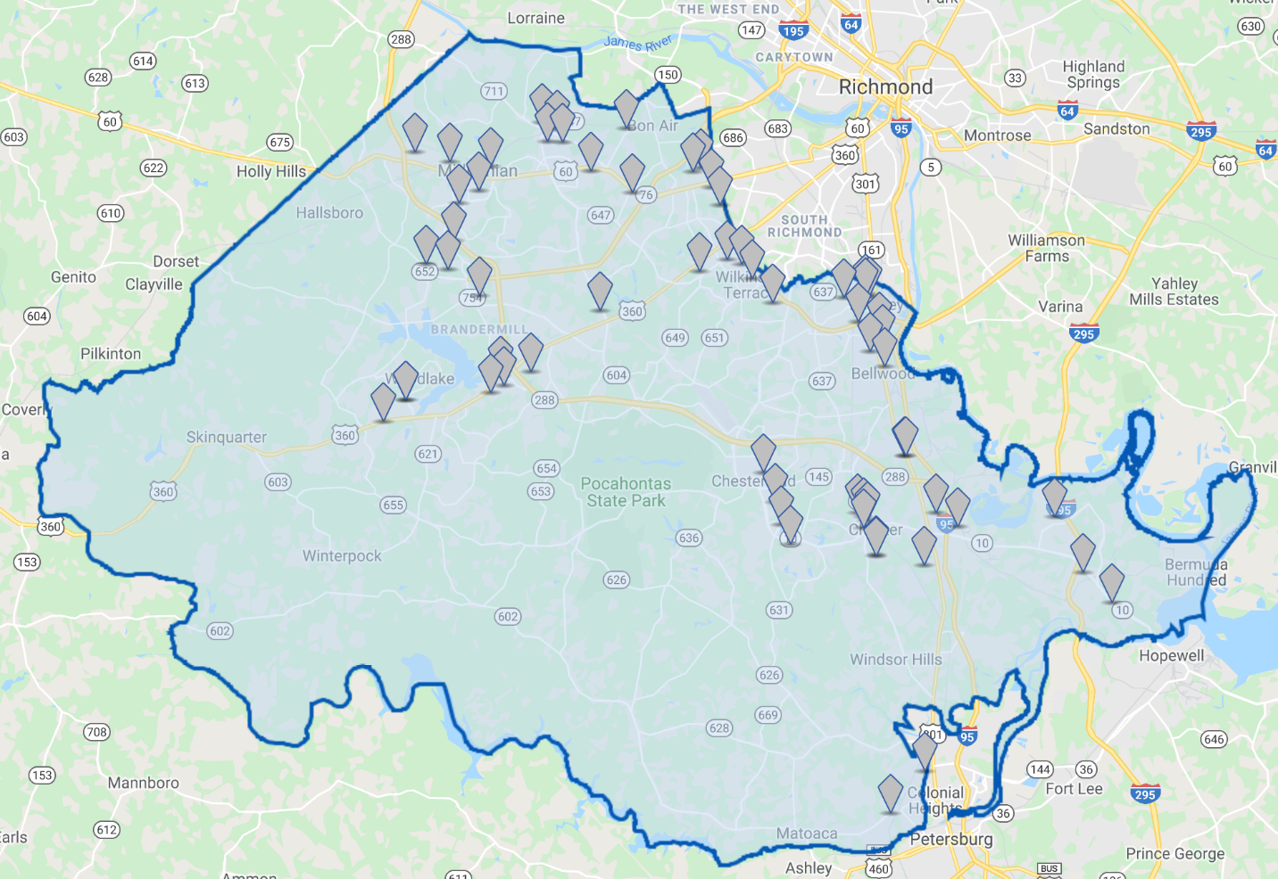

Costar Property Search.
Costar Property Search, as of November 2019.
Costar Property Search. The properties in this brief only include multi-family properties of 5 units or more. Single-family rental properties are not included this brief.

