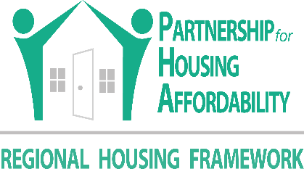
Partnership for Housing Affordability
Richmond Regional Housing Framework
Issue Brief

Naturally Occurring Affordable Housing: Richmond Region
Overview/Issue –
NOAH in the Region
92 percent of NOAH properties are affordable to a 1 person household earning 80% AMI ($48,400)
52 percent of NOAH properties are affordable to a 1 person household earning 60% AMI ($36,300)
43 percent of NOAH properties are affordable to a 2 person household earning 50% AMI (34,600)
25 percent of NOAH properties are affordable to 3 person household earning 40% AMI ($31,120)
More than 200 NOAH units have been lost since 2005.
- Naturally Occurring Affordable Housing (NOAH) are rental properties with no federal subsidy attached.
- The units are affordable to households earning 80% AMI and below ($62,200 for a family of 3).
- NOAH is a segment of the housing market that needs to be preserved.
Key Facts –
- The Richmond Region has 524 NOAH properties, totaling 73,775 units.
- The average NOAH property is more than 38 years old.
- 10 percent of NOAH properties are affordable to households earning 30% AMI ($23,350) and below in the region, all within the city.
Policy Recommendations –
- Establish a NOAH preservation program to encourage owners to preserve the quality and affordability of their units, employing both incentives (performance grants, tax rebates) and penalties (code enforcement, fines).
- Create a system to monitor and track NOAH.
- Community development organizations should explore acquisition of NOAH through special loan and equity funds.
Implications –
- NOAH owners face market pressures to add improvements and increase rents or to defer maintenance and preserve affordability.
- NOAH owners may prioritize cash flow over housing quality.
- Preserving NOAH can help owners ensure their housing is maintained in good condition, and that the monthly cost of housing is not burdensome.

Costar Property Search
Costar Property Search.
Costar star ratings are based on building quality. 1 and 2 star properties are older buildings with less amenities and few green certifications. Architectural design, exterior spaces, landscaping, and structural systems also contribute to ratings.
37 percent of the region’s NOAH is 1 and 2 star, while 42 percent is 3 star.
1 and 2 star properties are affordable to the lowest income households but are declining throughout the region.

